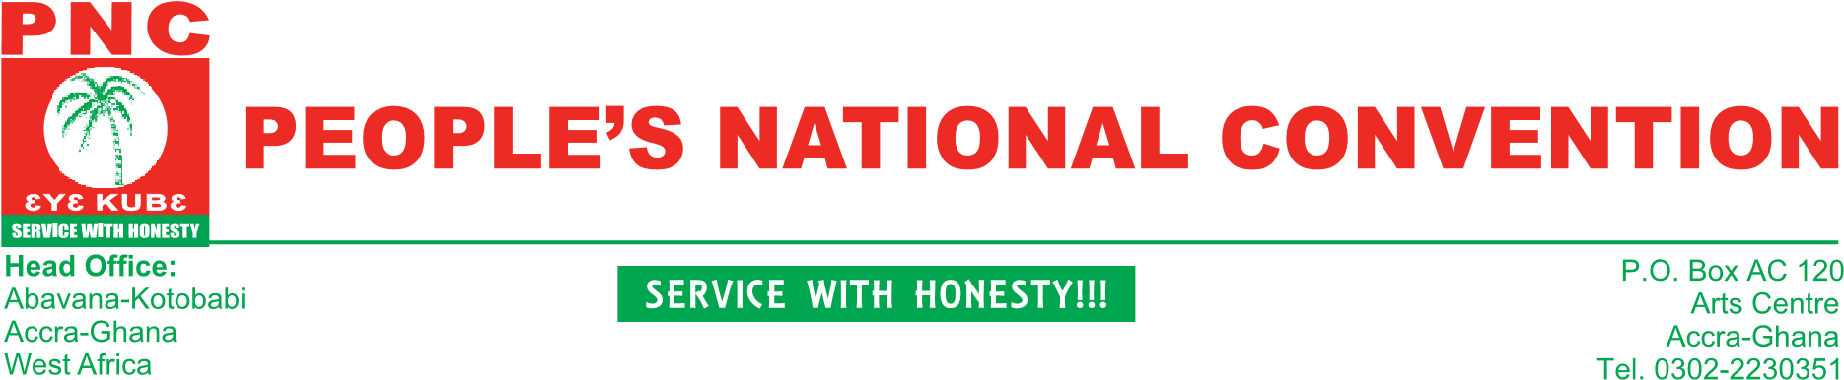

22nd February,2019.
Press Release
PNC'S GOODWILL MESSAGE TO THE NDC AHEAD OF THE PARTY’S PRESIDENTIAL PRIMARIES ON SATURDAY 23RD FEBRUARY, 2019.
We send you our warmest felicitations and greetings of comradeship from the leadership and of the entirety of the PNC as you go to the polls to elect a presidential candidate to lead your party into the elections of December 2020.

As this marks a quantum leap in your party's reorganizational drive towards the 2020 elections, it is fitting for us an important player in Ghana's political turf to wish you an incident free and credible elections that would produce the best candidate for your party ,

In these unfortunate times of political militia and the attendant violence, that is fast consuming Ghana's democratic dividends, we create your indulgence to rope in any militia groups whose activities might create needless tension and possibly mar the beauty and credibility of the process. We expect you to collaborate and co-operate with the security agencies to carry out their lawful duty of maintaining law and order on a big day such as this.

The PNC sees itself as an ally of yours in opposition with the onerous responsibility of constructively critiquing the performance and conduct of the government of the day by proffering better alternative policies. This would put the government on its toes and bring the best out of them for a better Ghana. In this regards, we expect you to elect a candidate who would meet these expectations of the masses of Ghana.

On behalf of our members and indeed Ghana as a whole, we implore delegates, supporters, sympathizers and activists of the NDC to conduct themselves in the best possible way and live above reproach before, during and after the elections. They must know that this is just the first step in their quest to push the party out of opposition into government. Engaging in anything to the contrary would only worsen the woes of the party in opposition.

As the PNC wishes you the best of luck once more, may you have a free, fair, transparent and credible elections process. We equally wish all the aspirants the very best.

Bernard Mornah
(National Chairman)

