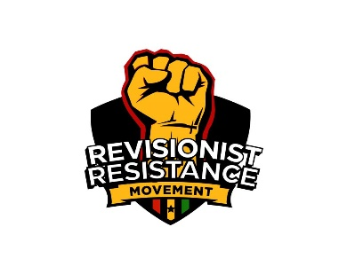
^{7h} January, 2019
Editors
All Media Houses

Dear Sir/Ma,
Constitution day as public holiday is meaningless,
The Revisionist Resistance Movement (RRM) Wishes to state without doubt that governments decision to set aside 7th January as Consitution day is without merit and at best meaningless, a distortion of history and pollution to the fertile minds of our youth.

Declaring a constitution holiday in place of the republic holiday is a clear manifestation of lack of appreciation of our history as a country and attempt to provoke citizens reaction.

Without retracing our historical journey as a nation, OSAGYEFOR Dr. Kwame Nkrumah declared Ghana's Republican Status on the 1st of July 1960 on the basis of an overwhelming approval of the Ghanaian people in a referendum conducted by the colonial power for a choice of full sovereignity through complete self rule or with the English sovereign still being our head of State. This day effectively sealed the full independence and self rule of Ghana. It also shattered colonial rule as it made Ghana a truly Independent nation. Thus the REPUBLIC OF GHANA has been same irrespective of whether civilian or military governments are in power,.
The fact that constitutional governments have been toppled cannot or does not in any way connote the abrogation of our Republic. Thus, the Republic of Ghana is static and unchangeable whereas a constitution of Ghana is dynamic and subject to change.

It is, therefore, incongruous for the government to substitute the celebration of the Republic day with the celebration of the constitution. We condemn this act totally. It smacks of dishonesty, it is disingenuous,subversive of law and order, a contempt of Parliament when an amendment is before the house for consideration. It also shows utmost disrespect to the people when petitions are pending against this obnoxious act. It is a disservice to the good people of Ghana and bastardizes our self worth as a people.

Yours in the struggle
Bernard Mornah (Convenor)
CC: All Political Parties
All Trade Unions

